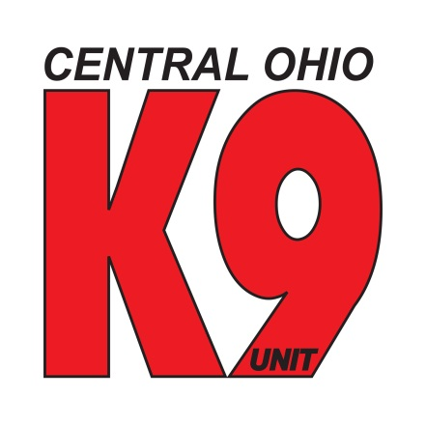

Central Ohio K9 Unit
7424 Braewood Drive
Independence, Ohio 44131
Tax I.D. # 30-0565781

Central Ohio K9 is a non-profit 501c3 organization made up of handler and dog teams from all over Ohio. The handlers and dogs are all certified Search, Rescue and Recovery. We have come together to provide the necessary resources to compliment the authorities and the community in finding missing persons and/or their remains to help families.
We all volunteer our time for different reasons, but all share a passion for dogs, and their ability to sense what humans cannot. We also share a passion for helping families like our own to find peace no matter what it takes. Central Ohio K9 is ready to assist anyone that needs our expertise including families and law enforcement. In order to continue our passion, each year we host a Golf Outing at Ironwood Golf Club. This year’s 3rd Annual Golf Outing will be on Saturday, June 22 2013.

Would you consider supporting our organization by making a donation, such as a gift card, gift basket or other items that we can use in our raffle or auction? Your contribution to the event will go a long way in making the outing a success. Your business name will be recognized on a banner at the registration area of the golf club.

In addition to donating items for the raffle and auction, we can accept financial contributions, Central Ohio K9 is a 501(C)3 Charity organization and your gift would be tax-deductible to the extent of allowed by law. Again, we will gladly acknowledge your financial support of our organization on a banner at the registration area of the golf club.

If you would like to make a donation, please mail your donation to:
Central Ohio K9 Unit, 7424 Braewood Drive, Independence, Ohio 44131. If your donation needs to be picked up by someone in person, please call us and we will make arrangements to pick it up from you.

Be Safe,

Ed Ripepi
Central Ohio K9 Unit
216-524-9180

